Video Game Sales: Genre, Trends, ad Regional Differences
DATA 110: Data Visualization and Communication — Project 1
Naveed Ahmad | October 28, 2026

Introduction
There are many ways to analyze video game sales, including the type of game, the year of release, and the geographic region. In this report, a data set on video game sales was analyzed in order to see how the sales are distributed along different variables. The research question is: How do recorded video game sales vary by genre, over time, and across regions?
Three visualizations have been created in this report: a horizontal bar graph comparing the global sales by game type, a line graph showing the sales by year of release, and a grouped bar graph showing the sales by game type in North America, Europe, and Japan.

Dataset and Exploratory Data Analysis
The dataset I chose, contains 16,598 rows and 11 columns. Data elements include game rank, name, platform, year of release, genre, publisher, sales in NA (NA_Sales), EU (EU_Sales), Japan (JP_Sales), Other region, and global sales (Global_Sales). Sales data is in terms of millions of units. There are 12 different types of game genres in this dataset, and there are non-missing values of release year between 1980 and 2020.
Data preparation and quality
Data dimensions, column names, data types, descriptive statistics, and the existence of missing values in the dataset were assessed in the exploratory analysis. Missing values are found in the Year column with 271 records (1.63%) and the Publisher column with 58 records (0.35%), while there are no missing values in other columns according to the preliminary check for missing values.
For the visualization of annual sales, the records having missing Year or Global_Sales were dropped, and Year column was made an integer to perform grouping by the year of release. While in the creation of the genre chart, the records having missing genre or global sales were dropped. The total number of genres and regional sales were computed using group by operations.
Explored relationships
My analysis focused on three relationships: 1. Genre and total recorded global sales, 2. Release year and total recorded global sales, and 3. Genre and regional sales.
Visualizations and Findings
Figure 1. Total Global Video Game Sales by Genre
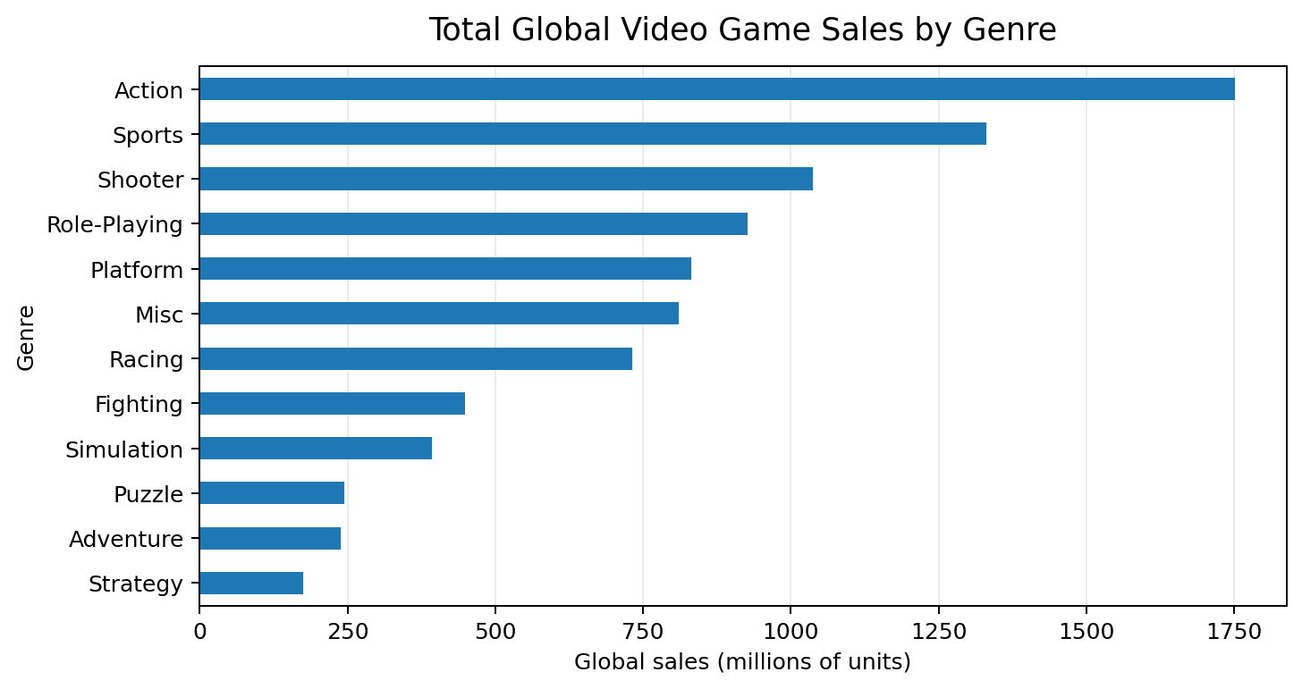
Total recorded global sales, in millions of units, summed across game records for each genre.

The game genre that has a maximum number of sales in the world is Action, which has sales worth 1,751.18 million. The second most sold game genre is the Sports game genre with sales of 1,330.93 million, and then is the Shooter game genre, which has sales worth 1,037.37 million, and then Role-playing game genre with sales of 927.37 million.

Figure 2. Recorded Global Sales by Release Year
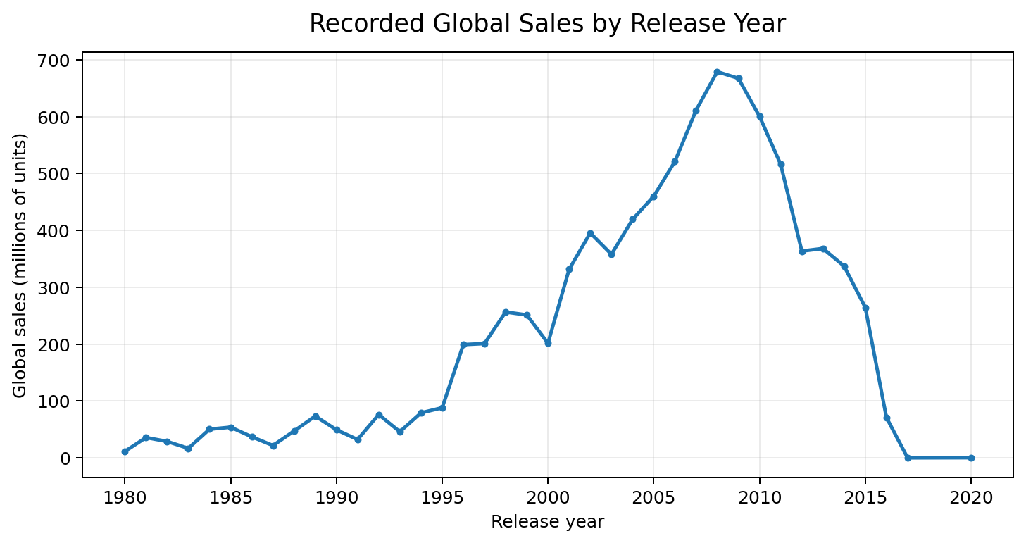
Total recorded global sales, in millions of units, summed by release year for records with a known year.

The highest total value recorded annually in the data set is from 2008, with a total value of about 678.90 million units. Other total values can be found in 2009 and 2007 with total values of 667.30 million and 611.13 million units, respectively. The line chart is an appropriate chart to use in identifying variation in total values across consecutive years.

Figure 3. Video Game Sales by Genre and Region
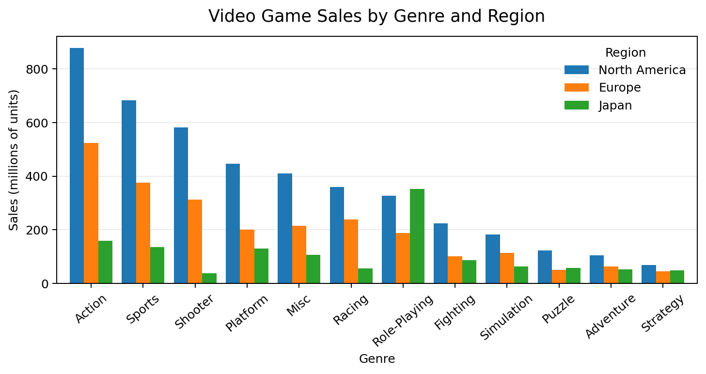
Recorded sales by genre for North America, Europe, and Japan, in millions of units; Other_Sales is not shown.

From the regional figures, we can see that there is relatively high sales of Action games in North America and Europe. The number of Action game sales in North America is about 877.83 million, while that of Europe is about 525 million. In the case of Japan, Role Playing games make up a considerable total of about 352.31 million. The grouped bar chart helps to compare the three regions for each genre. Since the Other_Sales variable is missing, the figure shows comparison of the three regions instead of giving an account of the total global sales.

Conclusion
Patterns found by this exploratory analysis include three key findings. First, the category with the highest total recorded sales figures on a global scale is Action, followed by Sports and Shooter respectively. Second, 2008 was the year with the highest recorded sales figures. Third, different patterns were found for different regions: Action is a highly recorded category in North America and Europe, whereas Role-Playing is particularly prevalent in Japan.
The results show how visualization can transform an ordinary dataset into an interesting, evidence-driven story. Nevertheless, the results are constrained by the scope of the data and should not be automatically applied to all games, sales or periods in the industry. Other analyses might be conducted to analyze sales by platforms, compare genre patterns over time or find differences at the level of publishers. In such a way, more information will be gathered without any assumption of causality behind the detected patterns.

Reference
Kaggle. (n.d.). Video game sales datasets [Dataset search results]. https://www.kaggle.com/datasets?search=video+game+sales

Appendix
These analyses were completed in Google Collab by loading, inspecting, grouping and summarizing the data

